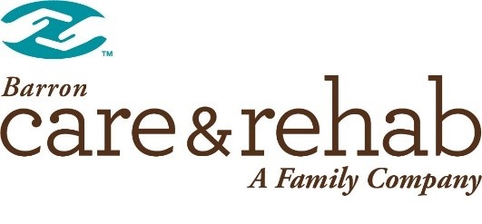
COVID-19 Update
Friday, July 17, 2020
Dear Residents, Patients and Family Members:
Care & Rehab Barron is following the requirements from the Centers for Disease Control and Prevention (CDC) and the Center for Medicare and Medicaid Services (CMS) for resident, patient and family reporting of COVID-19 activity in our care center as of the date of this notice.
# of active (suspicious or confirmed) COVID cases in residents or staff: 0

Cumulative data from May 8th, 2020.
Total # confirmed cases of COVID-19 in residents and/or staff: 0
Total # of symptomatic clusters (3 or more within a 72-hour period): 0

For resident positive test: We will notify residents and their representative(s) of their condition and implement protocols for their care and treatment.
For staff positive test: We follow guidance from the CDC and CMS regarding their safe return to work.
Due to government privacy requirements, we cannot divulge specific information about the individuals who have confirmed or suspected COVID-19, unless they are your family member and you have the necessary permissions to receive such information.
The safety and wellbeing of our residents remains our top priority. We are doing what we can to limit the spread of COVID-19 within Care & Rehab Barron, including staying in very close communication with local and state health officials to ensure we are taking all the appropriate steps under current circumstances.
Based on guidance from the Centers for Disease Control and Prevention (CDC) and the Center for Medicare and Medicaid Services (CMS) to reduce the spread and impact of COVID-19, we are using strategies such as:
- Enhanced infection control precautions
- Screening residents, staff, and essential visitors for expanded list of symptoms
- Restricting visitation and entry of people to the building
- Testing staff and residents for COVID-19 based on current protocols and availability of tests
- Postponing communal dining and activities
We know you are concerned about your loved one, but it is crucial that we continue with restricting visitation to reduce the spread of this virus to others. We will contact you directly if your loved one is suspected or diagnosed with COVID-19.
Staying connected with family members is incredibly important to our residents, and we encouraged you to connect with your loved ones through video chat, calling, texting, or on social media. Please contact our Community Life Coordinator, Keytun for information and scheduling of video calls at extension 500.
We need your help in battling COVID-19. Please visit the CDC website (www.cdc.gov/coronavirus) to learn how you can help prevent the spread in our community, since continued spread in the larger community increases the chance the virus will work its way into our building.
This is a difficult time for everyone. We will continue to provide you with updates. Please know that we are adhering to guidelines from the local and state health departments, which continue to evolve as we learn more about this virus.
We know that you may have questions and we encourage you to contact our center. Please call us at 715-537-5643 for updates on the status of your loved one.
Sincerely,
Len Fast, Administrator
Care & Rehab Barron

